

Submitting Artwork to Lintel International Video

Lintel uses a thermal transfer method for labeling CD’s and DVD’s. This is a direct to disc process, we do not use paper labels on the media. We can also print jewel case inserts and DVD case wraps on our HP Laserjet printer if the project calls for it.

The specifications for submitting artwork to Lintel vary depending on the type of project you need completed. Please follow the appropriate guidelines for the style of print we are working on for you. If you have any questions, please let us know.

When your artwork is ready, feel free to deliver it via CD, e-mail or FTP. All email messages must be under 10MB in size due to ISP restrictions. Zipping or Stuffing the files is acceptable. The Lintel FTP address is www.lintelvideo.com/upload.html. Use the instructions at the bottom of the page to upload your files to our server. Also, please include a printed sample of your artwork with your master. It may be directly on the disc, or printed on a piece of paper.

The content of your CD or DVD may be the most important part of the project, but the disc label is the first element your users see. Lintel will do it’s best to work with you to make this first impression a memorable one.

Thermal Black Print

- Applicable only for text and line art logos
- Use template “Thermal black disc”
- Acceptable file formats: Word Document, Adobe (PDF, Photoshop, Illustrator, JPEG or TIFF)
- Provide logos as separate graphic files (300 dpi)
- CD labels are printed on silver or white, DVD labels are printed on white
- Specify/provide fonts and point sizes if other than Ariel

Some examples of black print labels:





Thermal Color Print

- Applicable only for labels with any color element or grayscale images
- Process cannot guarantee PMS color matches
- Use template “Thermal color disc”
- Acceptable file formats: Adobe (PDF, Photoshop, Illustrator, JPEG or TIFF)
- Provide artwork at 300 dpi, RGB file
- Include linked elements with artwork
- Outline/rasterize fonts or include font files with artwork
- Do not flatten keyline or template layers into artwork. These must be on separate layers from the artwork
- Allow background image/color to bleed through center hub, and off disc edges

If the printed disc will look like this:
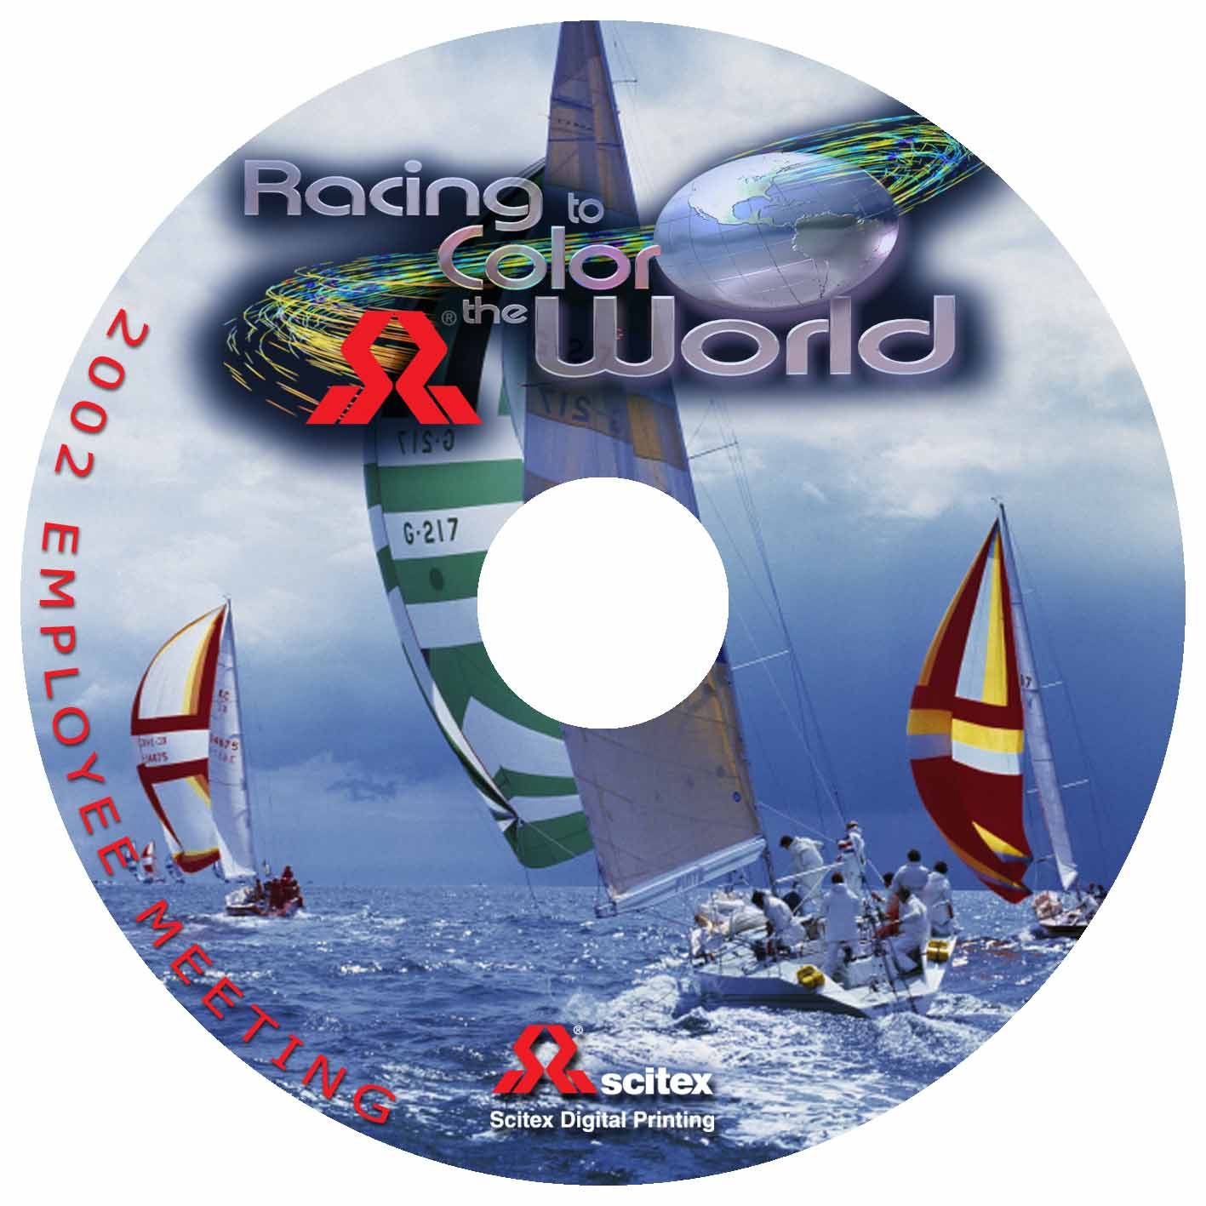

Then the submitted artwork should look like this:

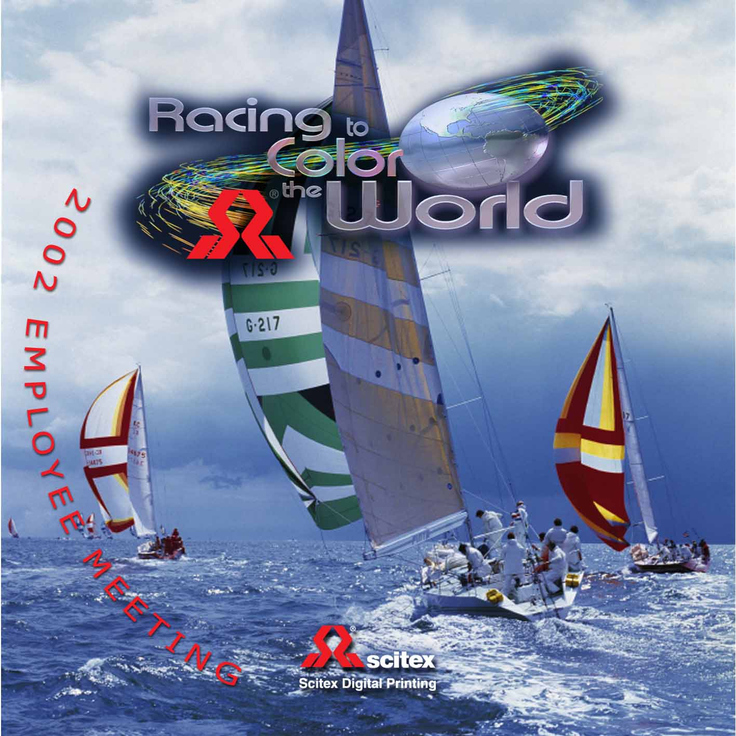

Color Screenprint

- Applicable only for replication projects
- Use template “19mm hub disc” or “38mm hub disc”
- Acceptable file formats: any vector art graphics package
- Provide artwork at minimum 300 dpi, CMYK file
- Include linked elements with artwork
- Outline/rasterize fonts or include font files with artwork
- Include PMS color values if applicable (*some perceived color shift may occur when printing on silver substrate. Colors are matched to the PMS numerical specification included in your file)
- Include layer for the white flood coat
- Do not allow bleed outside printable area

Properly submitted art w/registration marks:



Printed Material

- Applicable for Jewel case inserts, front & tray and DVD case wraps
- Use appropriate template
- Acceptable file formats: PDF, Photoshop, Illustrator, JPEG, TIFF
- Provide artwork at 300 dpi
- Include linked elements with artwork
- Outline/rasterize fonts or include font files with artwork
- Do not flatten keyline or template layers into artwork. These must be on separate layers from the artwork
- Allow for bleed off edges





